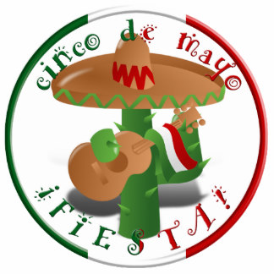

$30.00 per booth $50.00 per booth with electricity

Business Organization Name:

Authorized Representative Lessee:

Mailing Address:

Contact Information:

I, , an authorized representative of

Hereby agree to lease from the Brookshire Cinco de Mayo Festival Committee a $30.00 $50.00
Booth space (s) at the 2022 Cinco de Mayo Festival which is being held on May 7th & 8th, 2022 at the Hovas Park in Brookshire. Checks are to be made payable to the: Brookshire Cinco de Mayo Festival.
All food vendors must obtain a Food Handling permit at City Hall located at 4029 Fifth St. in Brookshire.

Please read and initial all applicable lines:
____ I agree that there is a fee of $30.00/$50.00 per booth and agree to pay the amount.
____ I agree to keep booth open and manned from 10:00 a.m. until 6:00 P.M.
____ I agree to have all vehicles out of the festival area no later than 11:00 A.M.
____ I agree that the booth will not be dismantled prior to 5:00 P.M.
____ I agree to keep area clean during event and to clean up after the event
____ I understand that I must supply any tables, chairs, display materials and protective covering for my booth.
____ I understand that the Cinco de Mayo Festival Committee retains domain of all alcoholic beverages.
____ understand that the Cinco de Mayo Festival Committee reserves the right to restrict any and all inappropriate
material from being sold or displayed at the festival site.
____ I assume complete liability for occurrences within or around leased space and to provide insurance coverage
required by lessor.
____ I understand that the City of Brookshire or the Cinco de Mayo Festival Committee bares no liability to any
lessee.
____ I understand that no booth will be allowed to sell garage sale items
____ I understand that no booth will be allowed for any political purposes or with the intent to distribute
materials.
I understand that no booth will be allowed to sell BB Guns, Pellet Guns or knifes.

Any Lessee failing to comply with all applicable terms listed above will be required to remove the booth from the festival site at the Cinco de Mayo Festival Committee Personnel. This lease agreement shall not become effective until accepted by the Cinco de Mayo Festival Committee and shall constitute the entire agreement between parties.
There will be NO REFUNDS under any circumstances or conditions including those related to weather.

Authorized Signature Date

All payments must be made payable to the Brookshire Cinco de Mayo Festival
Please return the application contract to City of Brookshire, P.O. Box 160, Brookshire, TX 77423

